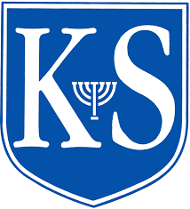
Careers Newsletter Edition 3 Spring 2023/Nissan 5783

Learning. Charity. Community.

WHAT’S BEEN HAPPENING THIS TERM
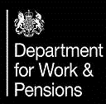 | January: Y10 – ‘World of Work’ sessions with DWP  February: Y9 – ‘Making your GCSE’ choices sessions with DWP
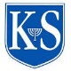 | February: All years Careers Club launched!  Tuesday lunchtimes.
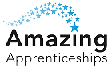 | March: Y11,12,13 CAREERS FAIR  with Red Bull Racing, Deloitte and Leonardo, as well as staff from the Met Police, Amazing Apprenticeships, and Waltham Forest College  Our students had the opportunity to visit the stands and find out more about the sectors represented and what qualifications and skills are needed to enter that profession.
 | Dell webinar - working in the IT sector and the different options available for young people within that industry
 | CGI’s Cyber Escape Challenge at Here East, Olympic Park–
 | March – April: Y7 Introduction to the Careers platform

COMING UP:
May: Y8 – ‘World of Work’ sessions with DWP

Y12 Focus Groups where students can gain advice from professionals in different job sectors.

STUDENT OPPORTUNITIES & EVENTS FOR Summer:
SKILLS LONDON VIRTUAL EVENT

↓↓
- GCSE and A-Level | BusinessLDN (previously London First)
- Apprenticeships | BusinessLDN (previously London First)
- Degree level | BusinessLDN (previously London First)
- Degree level | BusinessLDN (previously London First)
- Career showcase | BusinessLDN (previously London First)

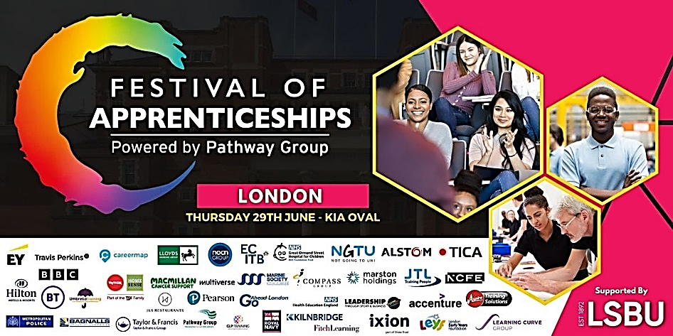
Students use this package where they can take the quiz to identify their likes, strengths and interests. Morrisby allows them to explore different job roles, watch videos, and keep a ‘favourites’ list.
If your child would like to come and speak to a careers adviser then please ask them to either email Mrs Shepherd (Careers coordinator) dshepherd20.317@kkshs.uk or Ms Tye (part time SEND adviser) mtye1.317@kkshs.uk or call into the office on the first floor to book a meeting.

We hope that you have found this edition useful and would welcome your feedback and any suggestions for information that you would like to see if future editions.
Careers Team at King Solomon High School

