Careers Newsletter Edition 4 Summer 2023/Sivan 5783

Learning. Charity. Community.

WHAT’S BEEN HAPPENING THIS TERM UP COMING VISITS
 | May: Y8 – ‘World of Work’ employability skills sessions with DWP
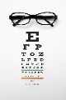 | Y12 Career Focus sessions:  Medicine Optometry Teaching  Sarah Stoll Louise Jagriti Jyoti
 | Y12 CV writing session – with Mrs Shepherd
UEL Summer School Tues/Weds/Thurs 4 –20 July  Engineering, Business & Finance Law & Justice Music production Media, Film & Journalism 16 – 18-year-olds Click for details | Y7 have all registered and been able to explore 1 career during Careers sessions.
Y12 Bank of America Insights
Y7 Disney Theatre Careers

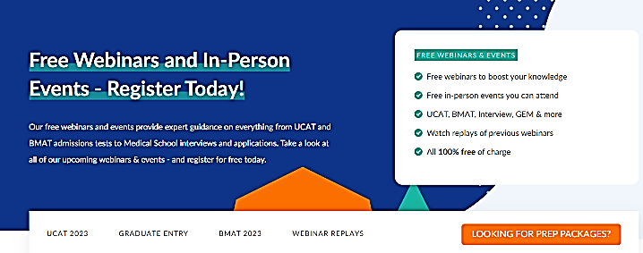
STUDENT OPPORTUNITIES & EVENTS FOR Summer:
https://www.themedicportal.com/application-guide/get-into-medical-school/events/?v=79cba1185463

Introducing Soaring to Success®: Empowering
Students in Aviation and Aerospace - a program
Students use this package where
they can take the quiz to identify their likes, strengths and interests. Morrisby allows them to explore different job roles, watch videos, and keep a ‘favourites’ list.
aimed at 13-17-year-olds with no prior connection
to aviation or aerospace industries.
For further information email Roxanne Hurry at
roxanne.hurry@airleague.co.uk

If your child would like to come and speak to a careers adviser then please ask them to either email Mrs Shepherd (Careers coordinator) dshepherd20.317@kkshs.uk or Ms Tye (part time SEND adviser) mtye1.317@kkshs.uk or call into the office on the first floor to book a meeting.

Spotlight on our KS alumni- Where are they now?
What did you do after leaving KSHS? /Where do you work?

Mahnoor Imtiaz
K S 2016 - 2022
I began working in the Kehila Department as an Informal educator.
Why did you choose this job?
I was offered this job and saw it as an incredible opportunity to give back to the school for all the support they have given me the past 7 years.
What are your main duties?
I help plan and organise events and trips for the school. This includes religious festivals such as Purim and Chanukah and running weekly lunch time programmes for our Year 7s. I have also managed projects such as the Alan Senitt Programme to help our upper school students build interpersonal skills which I feel are vital for their future.
What do you plan to do with your new skills?
This job role has built up my confidence and organisational skills greatly. It has given me the opportunity to feel more optimistic as I continue to pursue my career in Education.
What advice would you give to someone interested in pursuing a similar path?
I would say if you wish to go into teaching, be sure you really want to do it; teaching is a hard profession. It is, however, incredibly rewarding. As you start to pursue a career in Education, try to volunteer at a school so you can better understand what teaching is like. This helped me to solidify my decision for my future career.
We hope that you have found this edition useful and would welcome your feedback and any suggestions for information that you would like to see if future editions. Careers Team at King Solomon High School

